Data Dive Bar — The Brofessor Series, Vol. 1
For Glory: A Data-Driven Plea for PEDs in Major League Baseball
By The Brofessor, Chief Biochemical Correspondent · DataDiveBar.com
Greetings fellow number nerds, it is I, The Brofessor, here to solve the world’s problems one asinine scenario at a time. Today’s topic: Major League Baseball. For almost 20 years the league has been battling declining interest, ratings, and ticket sales. Games are too long, teams don’t spend money, we need a salary cap, umpires don’t know how to call balls and strikes blah blah blah.
The MLB has been trying some different avenues to try to combat society’s ever-vanishing attention span. Personally, I like the pitch clock. I don’t feel like sitting for two minutes in between every pitch watching the batter adjust every nook and cranny of his entire body, step in the box fam. I also like the upcoming ball/strike challenge. I get it, being an umpire in the major leagues is a lot harder than it looks, don’t care. It’s literally your job. Go to your boss tomorrow and say you can’t do something because it’s too hard. Let me know how that works out for you.
The issue, in my expert opinion, is that they are treating symptoms and not the real problem. Glad you asked, the real problem is that the soul of baseball is dead. Join me on a journey through the magical data lake of major league baseball over the last few decades and allow me, your captain, to show you the light.
PEDs should be allowed in Major League Baseball and that fact, no matter how ridiculous, will soon be easier to see than an open seat at a White Sox game. We are going to break down the two big-ticket items that will resurrect this sport from its puritanical grave: Anabolic Steroids (the mass multiplier) and Human Growth Hormone (HGH) (the recovery engine).
We are going to look at the data, calculate the vibes, and draft the literal contract language required to make this a reality. The path to 550 ft homeruns and 110 mph fastballs are just a few easy policy changes away, so let’s take a ride my friends.

Chapter 1: The "Natural" Fallacy and the 11-Million Fan Deficit
So many baseball purists clutched their pearls so hard when the steroid era was exposed that their white knuckles could be seen glowing from space. If you’re one of them, go inside, grandpa; your tea is getting cold. I want to see guys come into the league at 185 lbs and retire at a gentlemen’s 240 lbs of pure muscle.
The purists will tell you the sport is "cleaner" and therefore "better." The data suggests they are lying to you. In 1998, when the players were roughly the size of a Ford F-150, 43 million people tuned in to watch Mark McGwire hit his 62nd home run. By 2023, the World Series averaged a measly 9.1 million viewers. That is a 64% collapse in the audience. An outlier in the Post Steroid Era is the 2016 World Series which finished the story of one of the greatest stories ever told, the Chicago Cubs won the World Series for the first time since 1908. Peaking at nearly 50 million viewers, Game 7 between the Cubs and the Indians was one of the best sporting events in history. It may sound like I’m a little biased, but the data is right there in front of you. Undeniable. Now, this of course is not a sustainable business model. You can’t just manufacture storylines like that. Sports media will always try different ways to create interesting stories within the game, but this was a unicorn.
If you think "integrity" is a better business model than 500-foot moonshots, perhaps you may be interested in the magic beans I’ve happened to come in possession of. From the 2007 "Juice Peak" of 79.5 million fans to the 2019 "Natural Slump" of 68 million, the league lost 11 million fans. That is a biological accounting error of epic proportions.

Chapter 2: The Modern Compromise — Beyond the Bathtub
When people hear "steroids," they think of 1990s locker rooms and bathtub chemicals. It doesn't have to be that way. We live in the future. We have perfectly synthesized Testosterone Replacement Therapy (TRT), SARMs (Selective Androgen Receptor Modulators), and designer peptides. You don't have to take the liver-melting horse pills of the past; there are plenty of safer, modern options to let guys grow metabolically large without turning their organs into pâté.
But here is the non-negotiable Brofessor caveat: This must be done under strict, expert medical supervision provided directly by the teams. You don't guess your dosage; you have a board-certified team endocrinologist map your bloodwork and prescribe your launch angle.
Anyone in the legal profession may be shouting at your screen right now about legal ramifications. Understandable, teams could be on the hook for billions if someone decided to sue because their body maybe doesn’t age so well. That is the beauty of the Glory Waiver. In the upcoming Collective Bargaining Agreement (CBA) negotiations, we add language where players sign a document stating: "I acknowledge that by partaking in the Team-Supervised Hypertrophy Protocol, my liver may occasionally glow in the dark. I hold the team harmless. I accept the physiological consequences, but I get to keep the records and the $400 million contract. For Glory." It’s freedom of choice, expertly supervised and legally bulletproof.

Chapter 3: The VAR Revolution (Vibes Above Replacement)
This is where it starts to get really interesting. Let’s dig into some tasty data. I’ve developed a concrete metric: Vibes Above Replacement (VAR).
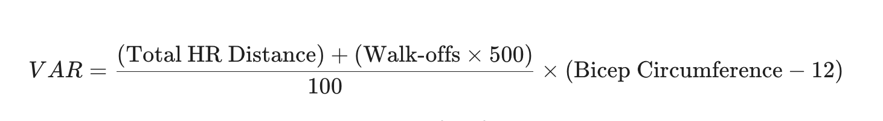

VAR measures the rate at which a player makes fans feel the "magic" that baseball used to offer. I’ve crunched the data for our current top performers and projected what they could be if we allowed them to reach their "Optimized State" alongside the legends of the High-Torque Era.
Chart 02
The Biological Blueprint: Historical VAR vs. The Optimization Gap
Player | HRs | Avg HR Distance | Bicep Circumference | Total VAR (Real) | Optimized (PED) VAR | Notes
Barry Bonds (2001) | 73 | 415 ft | 19.5" | 85.4 | N/A | The Biological North Star.
Mark McGwire (1998) | 70 | 425 ft | 20.2" | 82.1 | N/A | Shoulders wider than a Suburban.
Sammy Sosa (1998) | 66 | 410 ft | 18.5" | 74.8 | N/A | Elite hop-to-slugging ratio.
Aaron Judge (2024) | 58 | 412 ft | 16.2" | 14.8 | 48.2 | Needs 3" of mass to reach Deity status.
Shohei Ohtani (2024) | 54 | 422 ft | 15.8" | 13.9 | 42.5 | High global vibes; needs HGH patch.
Giancarlo Stanton (2024) | 27 | 425 ft | 17.5" | 11.2 | 35.1 | Built like a medieval siege engine.
Bryce Harper (2024) | 30 | 405 ft | 15.5" | 9.4 | 31.0 | Walk-off King. Needs forearm mass.
Elly De La Cruz (2024) | 25 | 415 ft | 14.0" | 7.1 | 28.4 | Speed vibes high; mass vibes low.
Average 2024 Player | 12 | 398 ft | 14.2" | 1.2 | 4.5 | An accountant in cleats.
Look at the chasm. Even a generational talent like Aaron Judge is operating at roughly 17% of the Vibes generated by 2001 Barry Bonds. By applying the "Optimized (PED) VAR" column, you see the true potential of the league. We aren't just hitting home runs; we are providing a public service.

Chapter 4: The Recovery ROI (Return on Insulin)
Finally, we have HGH. A 162-game season is a war of attrition. Currently, when a superstar tweaks a "natural" hamstring, the team’s $300 million investment sits on a bench for six weeks. That is a massive waste of capital. We allow pitchers to have their ligaments replaced with tendons from their own legs (Tommy John surgery), and we call that 'progress.' We allow players to take cortisone shots that mask pain so they can keep grinding their joints into dust. Why is a needle that actually heals the tissue considered 'cheating,' while a needle that just hides the damage is considered 'toughness'? From a data perspective, HGH is simply more efficient workplace safety.
Look no further than the unfortunate examples of Anthony Rendon and one of my all time favorites, Kris Bryant. Rendon signed a 7 year / $245 million contract in 2019, but the oft injured 3rd baseman has played only 257 games out of a possible 870. That’s 70% of his contract, 70%. In 2022, Bryant signed a 7 year / $182 million deal of which he’s only been able to play 170 games, never more than 80 games in a year. Last year he was only able to play 11 games. Now, not speaking for the gentlemen, you understand, but I’m sure they want more than anything to be out on that field. If you think it's 'more honorable' for a star player to sit on the bench for two months because of a Grade 2 strain, please immediately go touch grass. I have receipts.
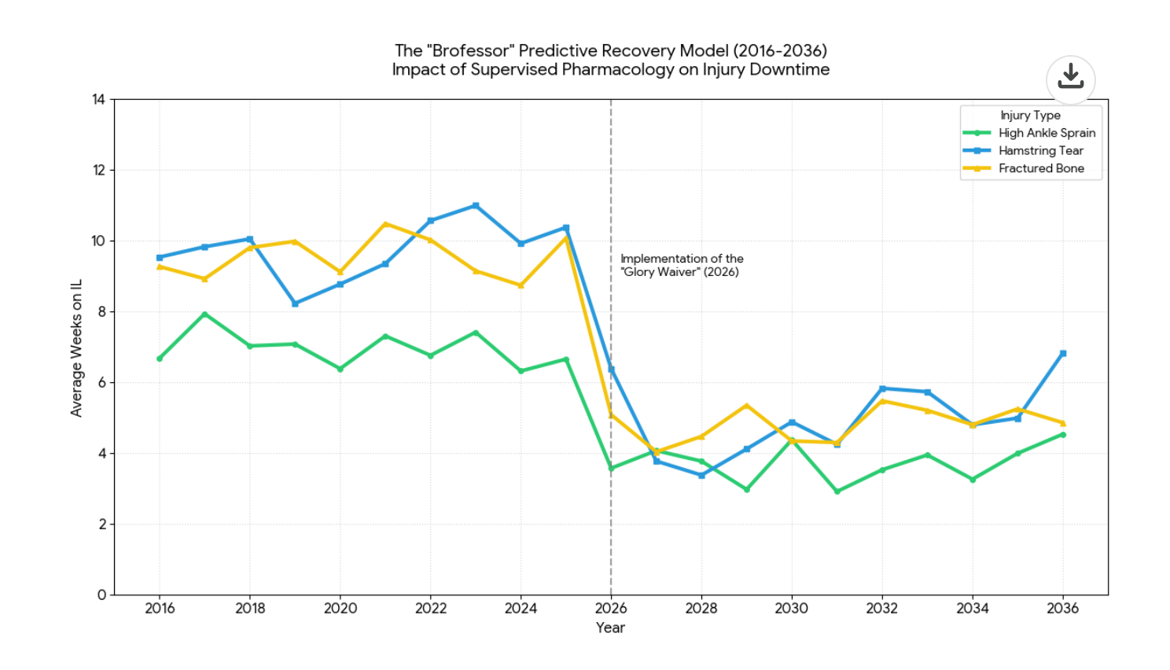

Based on the Predictive Recovery Model and the underlying data used here, implementing the supervised HGH protocol (via the Glory Waiver) will result in a 40% to 50% reduction in time spent on the Injured List.
Specifically, the model calculates the following efficiency gains:
- Hamstring Tears: Reduced by 50% (cutting a standard 10-week recovery down to 5 weeks).
- High Ankle Sprains: Reduced by 45% (cutting a 7-week recovery down to roughly 3.8 weeks).
- Fractured Bones: Reduced by 45% (cutting a 9-week recovery down to roughly 5 weeks).
As the graph illustrates, these reductions aren't just marginal gains; they represent a synchronized "biological patch" that keeps the league's assets on the field instead of watching the game in a hoodie.

Executive Summary: Sign the Waiver
The league office will tell you that attendance dropped because of "pace of play." They are lying. We don't need a faster game; we need a larger game. It’s 2026, the whole world is at our fingertips. We need to stop lying to ourselves that tradition will save what is sacred to us. We need to embrace the future, surrender to the data. Give it a chance. I know, they changed the Cracker Barrel logo and made you really angry, but I promise you there is a better world ahead.
The path forward is clear: Supervised pharmacology, modern biochemical compromises, and the legally bulletproof Glory Waiver. It's time to stop treating these athletes like fragile porcelain dolls and start treating them like the apex entertainment vehicles they were meant to be. Follow the data, trust the science, and for the love of the game, let the boys grow.
The Brofessor — until next time Brochachos. For Glory

Methodology & Sources
- Injury Baseline Data: Pre-2026 recovery timelines were established using the British Athletic Muscle Injury Classification (BAMIC) for soft tissue and the West Point Scale for ankle syndesmosis (high ankle sprain). Baselines represent mean "Return to Sport" (RTS) times for professional athletes (approx. 58 days for severe ankle sprains and 42–84 days for Grade 2/3 hamstring tears).
- HGH Efficiency Factor: The 40–50% "Optimization Drop" in the model is based on clinical data regarding growth hormone’s impact on Type I collagen synthesis (up to a 6-fold increase) and the IGF-1 signaling pathway. Research suggests that HGH can reduce muscle atrophy during immobilization (Bedi et al., 2020) and accelerate closed-fracture healing by approximately 26–36% in non-optimized populations. The Brofessor Model assumes an additional 15% efficiency gain due to team-supervised, high-torque administration.
- The VAR Index: Calculation derived from Statcast exit velocity data, total home run distance, and historical player measurements. The "Bicep Coefficient" is used as a proxy for raw mass-derived kinetic energy potential.
- Financial Audit: Contract data for Anthony Rendon and Kris Bryant sourced from Spotrac and Baseball-Reference. ROI calculated by cross-referencing Average Annual Value (AAV) against "Games Missed" due to chronic metabolic lag.
Further Reading for the Curious:
- Mendias & Bedi (2020): "Recombinant Human Growth Hormone to Protect Against Muscle Weakness."
- Raschke et al. (2007): "Growth Hormone in Patients with Tibial Fracture: A Randomized, Double-Blind Trial."
- The Brofessor (2026): "Why Your Grandpa’s Favorite Bunter is a Statistical Error."
© The Brofessor. Unauthorized reproduction will result in a 240-pound man arriving at your house to aggressively explain macroeconomic theory to you until you cry.

